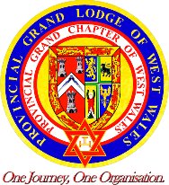Provincial Grand Chapter
of West Wales and
Provincial Grand Lodge of West Wales

Thursday 18th June 2026
Parc y Scarlets
Llanelli, SA14 9UZ

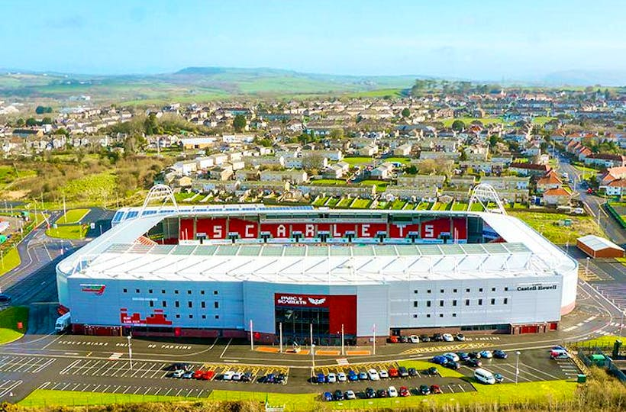

Main Entrance for Meeting, Lunch and Bars

The booking form for attendance and dining is attached within this supplement.
IMPORTANT NOTICE TO ALL BRETHREN
AND COMPANIONS IN THE PROVINCE
PROVINCIAL MEETINGS FOR 2026

The Annual Meetings of Provincial Grand Chapter and Provincial Grand Lodge will be held at Parc y Scarlets, Llanelli, SA14 9UZ on Thursday 18th June 2026 and it is hoped that you will make every effort to attend.

Provincial Grand Chapter please be seated by 10.00am for 10.30am start
The members of Provincial Grand Chapter, that is the Provincial Grand Officers, Present and Past, the Principals of a Chapter in the Province, and the Past First Principals who are subscribing members of a Chapter in the Province, are summoned to attend. Companions are invited (and encouraged) to attend but may not vote or speak on any resolution.

Provincial Grand Lodge please be seated by 2.30pm for 3.00pm start
The members of Provincial Grand Lodge, that is the Provincial Grand Officers, Present and Past, all Installed Masters who are subscribing members of a Lodge in the Province and Current Wardens of Lodges in the Province, are summoned to attend. Master Masons are invited (and encouraged) to attend but may not vote or speak on any resolution.

Please make a determined effort to attend the meeting(s). Indeed, why not make up a party of your Lodge or Chapter to support those of your members being appointed or promoted. This is a very special occasion and one of the few occasions that the RW Provincial Grand Master/ME Grand Superintendent asks for your support.

Between the two meetings is a luncheon, the cost of which is £26.50 inclusive of a glass of wine. This is a relaxed occasion in the middle of the day’s events so why not make the day complete by booking for an enjoyable meal served in pleasant surroundings.

Do please try to attend and support the Province.

Rhodri

P Rhodri Evans
Provincial Grand Secretary/Scribe E
PROVINCIAL GRAND LODGE & GRAND CHAPTER
Thursday 18th June 2026
BOOKING FORM FOR DINING
Please complete and return to:
Wyn Harries, Henllan, Eglwyswrw,
Pembrokeshire, SA41 93UP
Tel: 07970 684526 Email: dsec@wwmason.com
The preference is to receive the booking form by email and payment by bank transfer. NO CASH.
I shall be attending the Royal Arch Meeting Craft Meeting
I shall be attending Luncheon at a cost of £26.50
(Please tick the appropriate box)
Bacs payment; Ref Your Name: -
Account Name; Province of West Wales; Sort Code 30-91-68;
Account Number 00184493
Cheque for £26.50 (Cheque payable to "Province of West Wales")
Do you have special dietary needs
Details of dietary needs………………………………………………………..
FULL NAME _______________________________________________
ADDRESS _______________________________________________
_______________________________________________
TELEPHONE NUMBER _____________________________
E-mail address _____________________________
LODGE/CHAPTER NUMBER _____________________________
CRAFT MASONIC RANK BEFORE PROVINCIAL MEETING:
GRAND OFFICERS _____________________________
PROVINCIAL GRAND OFFICERS _____________________________
LODGE RANK (complete if not Grand or Provincial Grand Rank) W.Bro.* / Bro.* (* Delete as appropriate)
IMPORTANT NOTE
No reservations for luncheon can be accepted unless the application and remittance are received by 12th June 2026. Please also note that no luncheon refunds will be made for cancellations after the 15th June 2026.

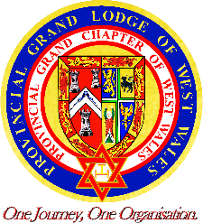

PROVINCIAL GRAND LODGE OF
WEST WALES
PRIF GYFRINFA TALAITH
GORLLEWIN CYMRU

Main Course

Cold Meat Plate consisting of
ham, turkey, beef
served with pasta, salad and boiled potatoes

-oooOooo-

Dessert

Strawberry flavoured Cheesecake with cream

-oooOooo-

Vegetarian/Vegan option are available

Please state clearly on the booking form any dietary requirements.

